

| **Name** | **Kaushambi Vats** |
| --- | --- |
| **KU ID** | **K2371041** |
| **Module Name** | **Market Research and Data Analysis** |
| **Assignment** | **Quantitative Analysis** |
| **Module Code** | **BM 7024** |

**Q.1. Analysis of Salesforce Image Ratings Between U.S. and Non-U.S. Customers**

**Objective:**

The purpose of this analysis is to determine whether there is a significant difference in how U.S. and non-U.S. customers perceive Salesforce's image. This information is crucial for HBAT as it plans to expand its operations in the U.S. The Marketing Director is concerned that U.S. customers may have a lower opinion of Salesforce compared to international customers, which could impact HBAT’s expansion efforts. An independent samples t-test is conducted to investigate these concerns.

**Hypotheses:**

- **Null Hypothesis (H₀):** There is no significant difference in the Salesforce image ratings between U.S. and non-U.S. customers.

- **Alternative Hypothesis (H₁):** There is a significant difference in the Salesforce image ratings between U.S. and non-U.S. customers.

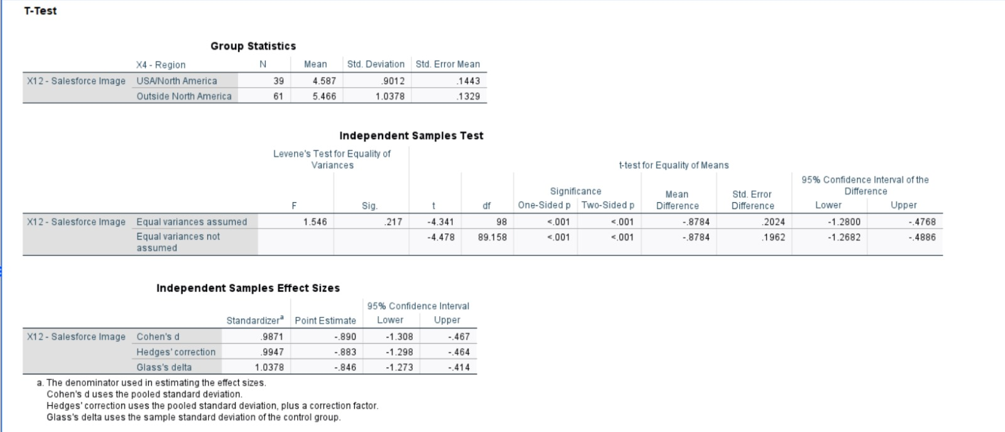

**Methodology:**

To test these hypotheses, an independent samples t-test was used. This test compares the mean ratings of two independent groups to determine if there is statistical evidence that the associated population means are significantly different. The process begins with Levene's Test for Equality of Variances, which helps determine which form of the t-test to use. The significance level (α) was set at 0.05.

**Results and Interpretation:**

- ***Levene's Test:*** The results indicated that the assumption of equal variances was not violated, allowing for the use of a standard t-test.

- ***Independent Samples t-test:*** The test produced a one-sided p-value of <0.001, which indicates a significant difference in Salesforce image ratings between U.S. and non-U.S. customers. Since this p-value is much lower than the alpha level of 0.05, the null hypothesis is rejected.

**Effect Size:**

- Cohen's d = 0.9871

- Hedge's g = 0.9947

These effect sizes are large, indicating substantial practical significance in the difference between the two groups' ratings.

**Mean Ratings:**

- U.S. customers: 4.587

- Non-U.S. customers: 5.466

According to the data, customers outside of the United States have a more favorable opinion of Salesforce.

**One-Tailed Test Justification:**

A one-tailed test was chosen because the hypothesis anticipated a specific direction in the difference: that U.S. customers would rate Salesforce’s image lower than international customers. Prior evidence or theoretical justification supports this strategy. The Marketing Director's concerns suggest that a lower rating in the U.S. could potentially impact business strategies and expansion plans, prompting the need to verify if the ratings in the U.S. are indeed lower than elsewhere.

**Conclusion:**

The statistical analysis supports the Marketing Director’s concerns that U.S. customers rate Salesforce’s image significantly lower than international customers. This information is vital for HBAT’s market penetration and promotional strategies in the U.S. It highlights the need for HBAT to improve the perception of Salesforce’s image among U.S. customers to better align with more favorable international perceptions. This can be achieved through targeted marketing efforts and customer engagement strategies tailored to address the specific concerns and preferences of the U.S. market.

**Q.2. Title: Quantitative Analysis of Customer Tenure and Perceptions of HBAT’s Product Line**

**Introduction**:

The primary goal of this analysis is to determine if there are differences in HBAT's product line ratings among customer groups with varying lengths of tenure. Understanding these differences is crucial for evaluating long-term customer loyalty and satisfaction, as longer tenure is often associated with higher levels of trust and satisfaction with the company's offerings.

**Methodology:**

**Data Collection:**

The study sampled 100 respondents, divided into three groups based on how long they have been customers of HBAT:

- Less than one year: 32 respondents

- One to five years: 35 respondents

- More than five years: 33 respondents

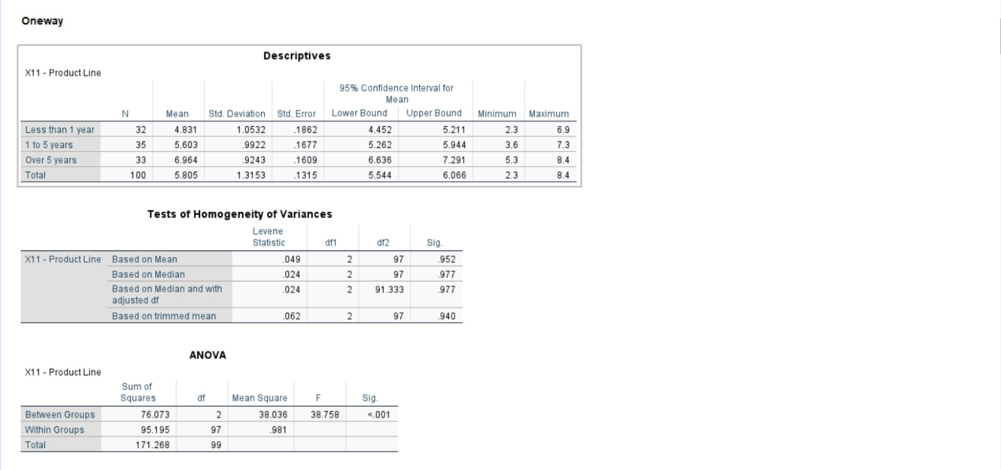

**Statistical Analysis:**

To compare the means of product line ratings across these groups, a one-way ANOVA (Analysis of Variance) was employed. This method is suitable for assessing differences among more than two independent groups.

**Hypotheses:**

- **Null Hypothesis (H₀):** There are no significant differences in the average ratings of HBAT's product line among the three customer tenure groups.

- **Alternative Hypothesis (H₁):** There are significant differences in the average ratings of HBAT's product line between at least two of the tenure groups.

The significance level for the test was set at α = 0.05.

**Statistical Tests and Results:**

**Descriptive Statistics:**

The analysis included the calculation of mean scores, standard deviations, and 95% confidence intervals for each tenure group, which provided initial insights into potential differences in product line ratings.

**ANOVA Results:**

The ANOVA yielded an F-statistic of 38.758 with a p-value of <0.001, leading to the rejection of the null hypothesis. This indicates significant differences in product line ratings among the tenure groups.

**Post Hoc Analysis:**

The REGWQ post hoc test was selected to further explore these differences due to the slight variations in group sizes. This test revealed substantial differences between all pairings of groups, indicating that customer satisfaction with the product line increases with tenure.

**Discussion:**

The statistical results suggest a positive correlation between customer tenure and product line ratings. This implies that longer-term customers have a higher level of satisfaction and loyalty towards HBAT's products. An effect size analysis, with an Eta-squared value of 0.444, confirmed a strong association between tenure and product evaluations.

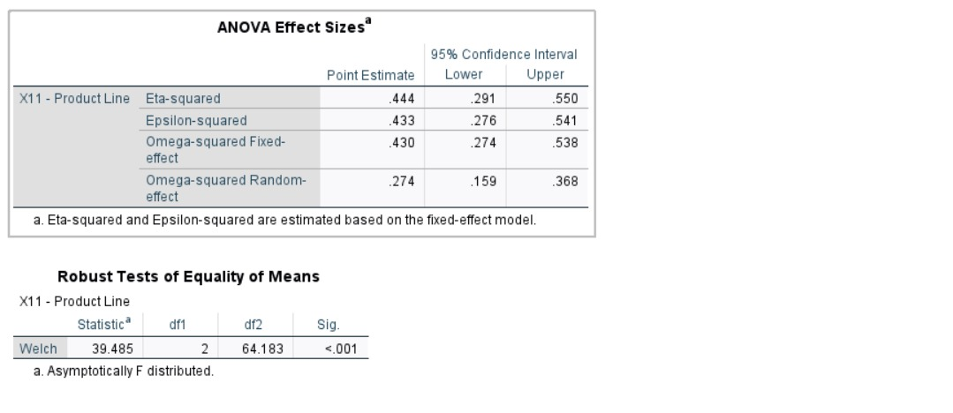

**Conclusion:**

The study's findings indicate that customers with longer tenure have a significantly more favorable perception of HBAT's product line. This highlights the importance of maintaining long-term relationships to enhance customer satisfaction and loyalty. These insights are valuable for developing targeted marketing and customer service strategies that focus on fostering long-term customer engagement and satisfaction. By leveraging these findings, HBAT can better cater to the needs of its loyal customers and improve overall customer retention.

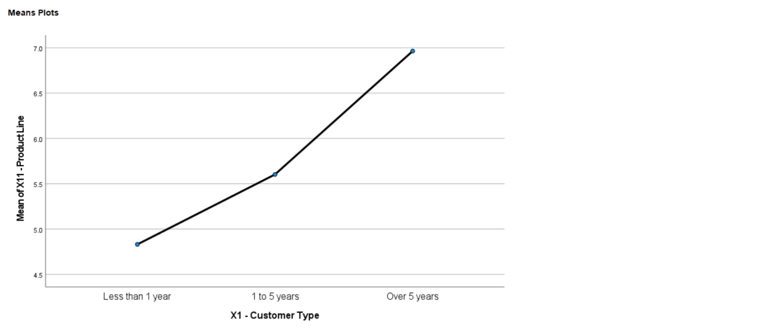

**Q.3 Evaluating Factors Influencing the Likelihood to Recommend: A Statistical Analysis**

**Introduction:**

Understanding the reasons behind customer recommendations is crucial for corporate growth. HBAT has identified several factors that may influence customers' willingness to recommend their products. These factors include technical support, product line, Salesforce image, warranty and claims, new products, price flexibility, and delivery speed. This analysis aims to evaluate the predictive power of these variables on the likelihood of recommending HBAT's products (variable X20).

**Hypothesis:**

- Null Hypothesis (H₀): None of the factors significantly predict the likelihood of recommending.

- Alternative Hypothesis (H₁): At least one of the factors significantly predicts the likelihood of being recommended.

**Methodology:**

A linear regression model was used to analyze the relationship between 'likelihood to recommend' (X20) as the dependent variable and the seven identified factors as independent variables. The analysis was conducted using SPSS software, which included diagnostics for collinearity and residual analysis to ensure the robustness of the model.

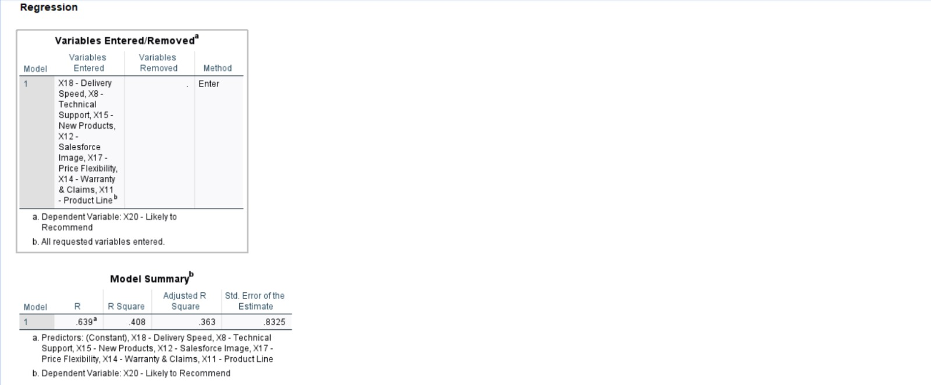

**Procedures:**

1. **Variable Entry and Regression Setup:** All seven factors were included in the regression model. Model fit, estimates, and collinearity diagnostics were incorporated into the analysis. The Durbin-Watson statistic was used to check for autocorrelation, and residual plots were generated to assess normality and homoscedasticity.

2. **Model Execution:** The regression model was executed, producing outputs such as ANOVA, coefficients, and diagnostics for multicollinearity and residuals.

**Collinearity Diagnostics:**

The Variance Inflation Factor (VIF) and tolerance levels were examined to detect multicollinearity among the predictors.

**Residual Analysis:**

Scatter plots and histograms of standardized residuals were analyzed to identify any deviations from normality and the presence of outliers.

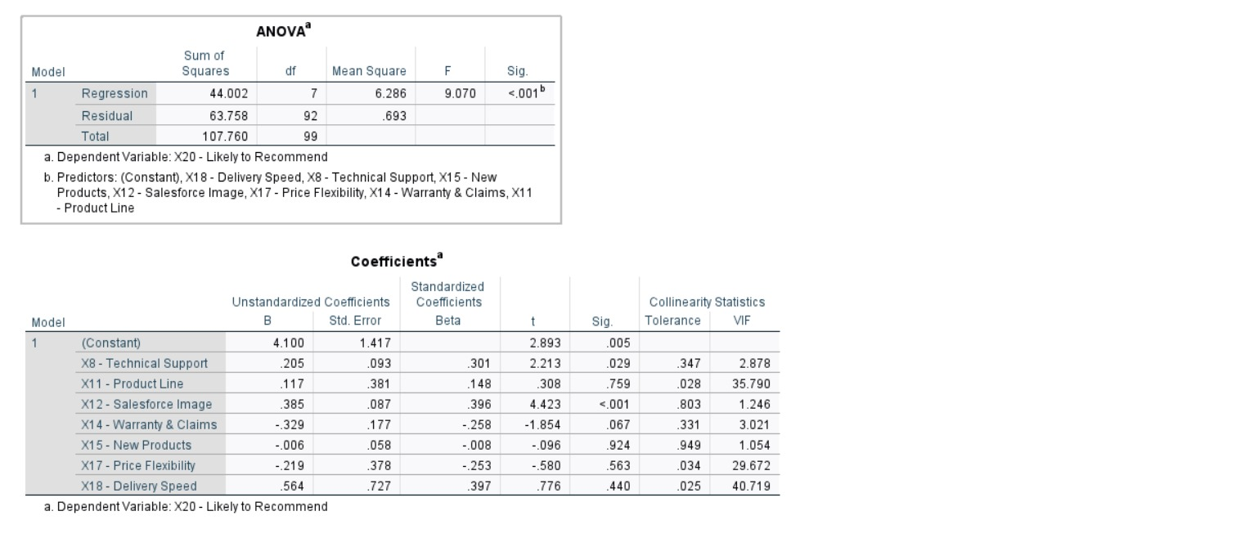

**Results:**

The regression model produced an R-squared value of 0.408, indicating that the independent variables explain approximately 40.8% of the variance in the likelihood to recommend. The ANOVA results showed a significant F-statistic (F = 9.070, p<0.001), leading to the rejection of the null hypothesis and confirming the model's statistical significance.

**Individual Predictors Analysis:**

- **Technical Support (X8), Salesforce Image (X12), and Delivery Speed (X18)** had significant positive coefficients, indicating a strong positive relationship with the likelihood to recommend.

- **Product Line (X11)** showed a high VIF, suggesting redundancy with other variables, especially new products, which undermines the reliability of its coefficient.

- **Warranty and Claims (X14) and Price Flexibility (X17)** had negative impacts on the likelihood to recommend, with Warranty and Claims showing marginal significance (p = 0.067).

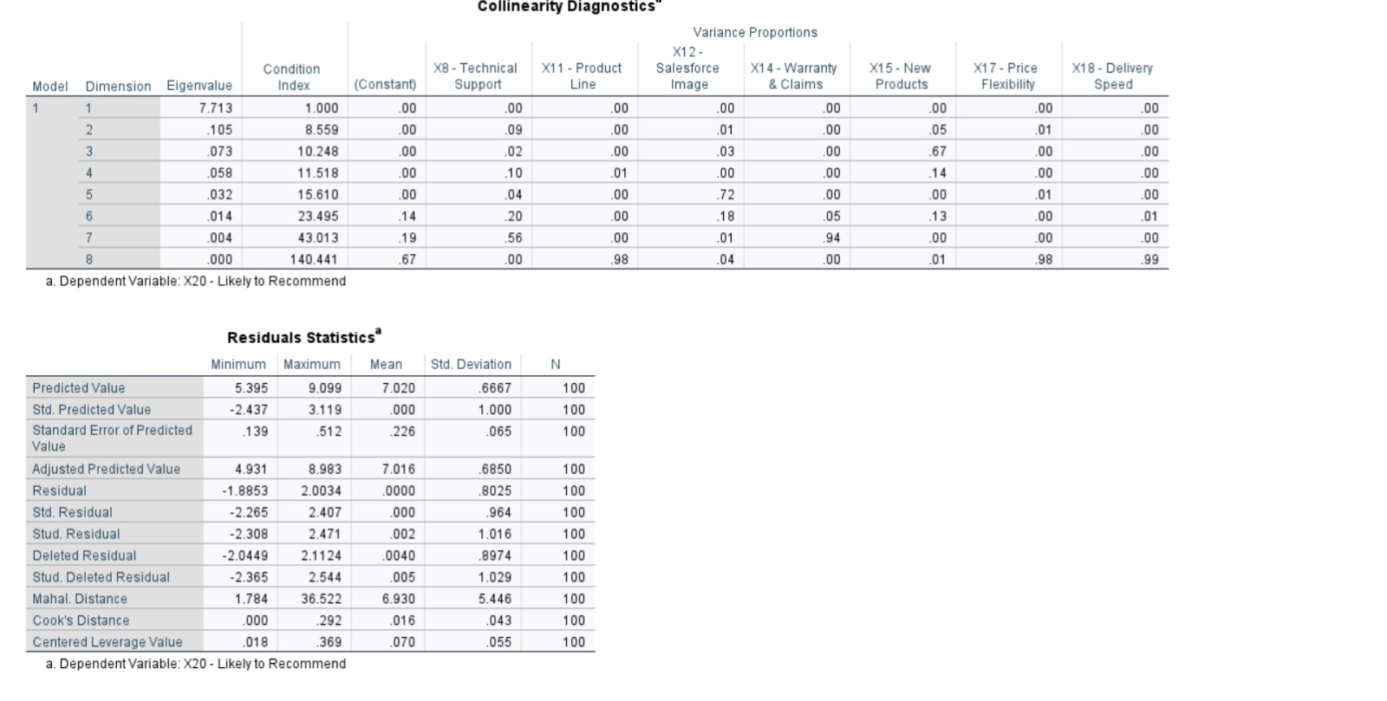

**Collinearity and Residual Findings:**

- Multicollinearity was detected in Product Line (X11), Price Flexibility (X17), and Delivery Speed (X18), with VIF values exceeding 10, indicating overlapping variance explained by these variables.

- Residual plots demonstrated a normal distribution of errors, and the Durbin-Watson value (2.233) indicated no substantial autocorrelation.

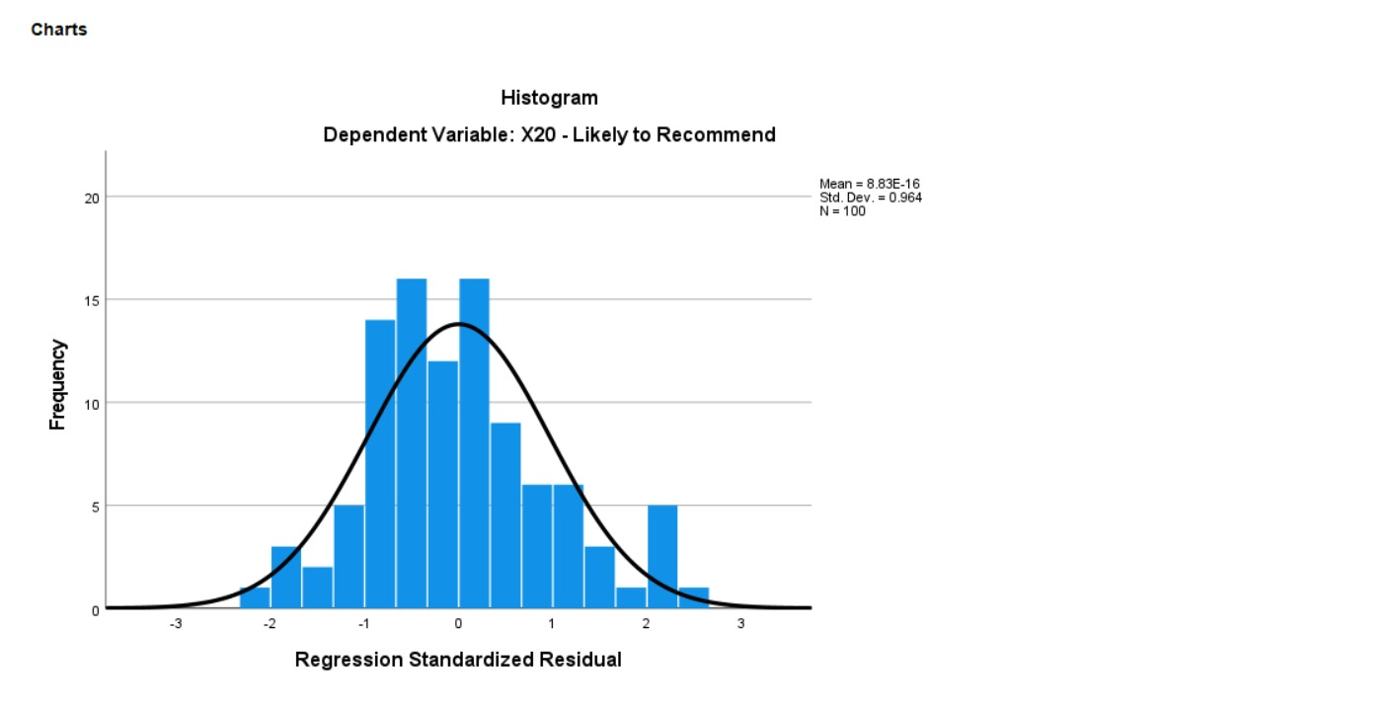

**Conclusion:**

The analysis reveals that technical support, Salesforce image, and delivery speed significantly influence the likelihood of recommending HBAT products. However, the presence of multicollinearity among some predictors, particularly product line, price flexibility, and delivery speed, suggests the need for model refinement. HBAT should consider revising the model by removing or combining highly collinear variables to better isolate the individual effects of each predictor. This refined model will provide clearer insights and enable more targeted strategic actions to enhance customer referrals. By addressing these issues, HBAT can improve its customer satisfaction and increase the likelihood of positive recommendations, driving further corporate growth.